Assignment-IV

Gokul Raam M

7179KCTKCTKCTKCTKCTKCTKCT19BCS026

1. Pull an Image from docker hub and run it in docker playground.

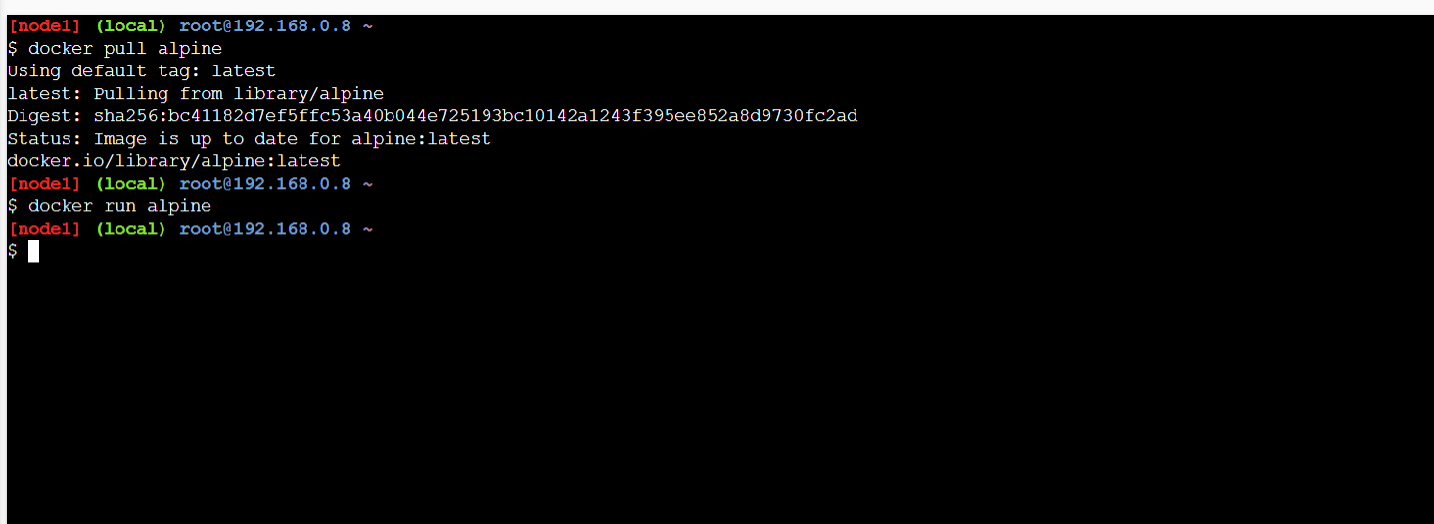

2. Create a docker file for the hello world application and deploy it in Docker desktop application.

Building the image from the file: docker build -t helloworld:0.1 .

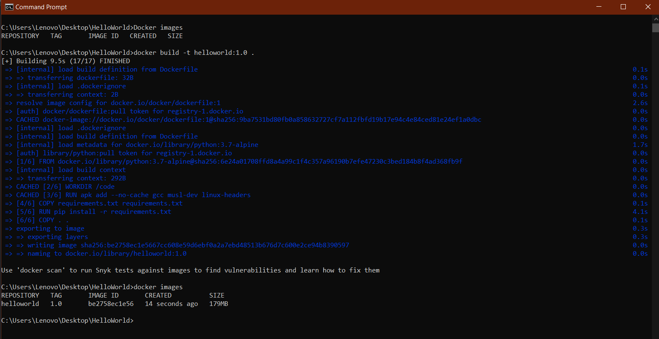

Docker desktop app:

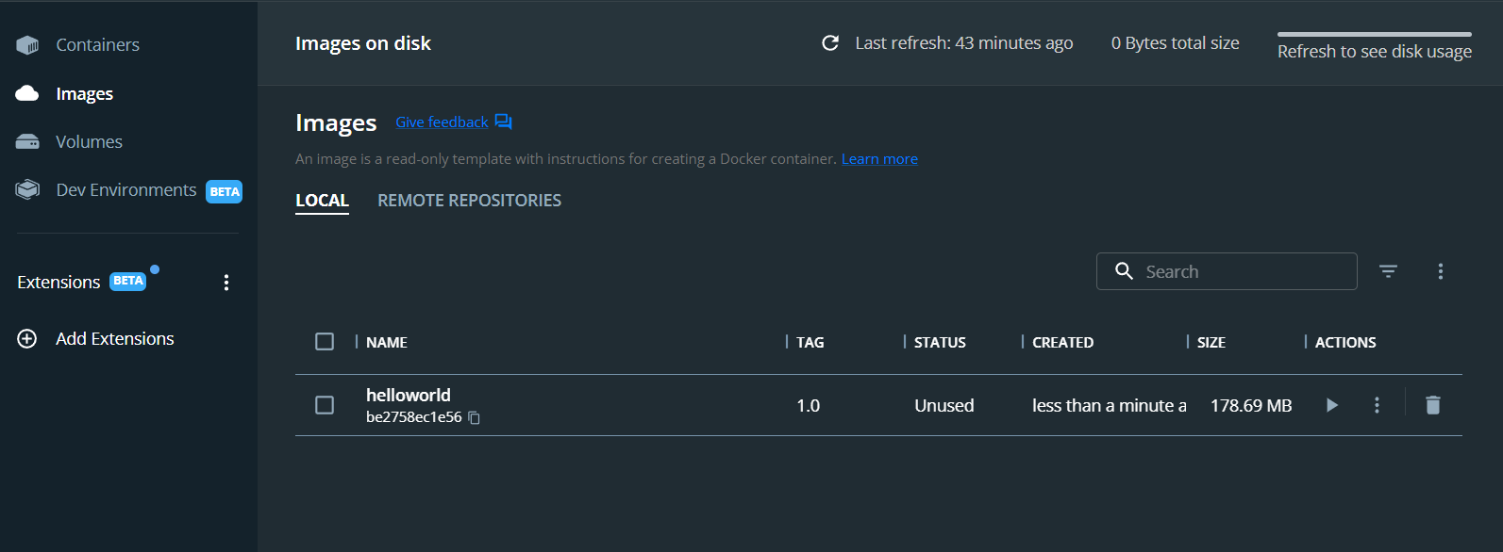

Run the container:

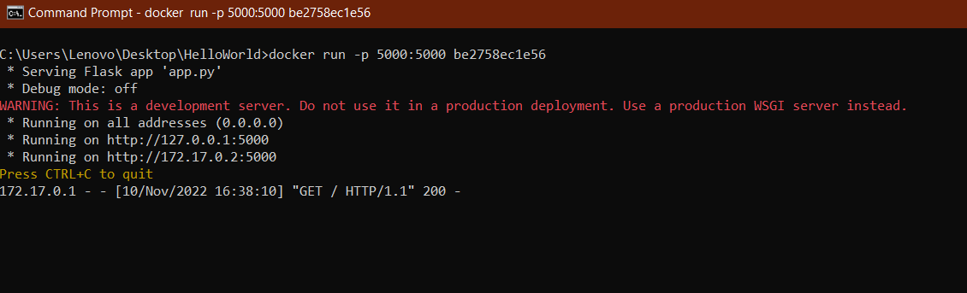

Output:

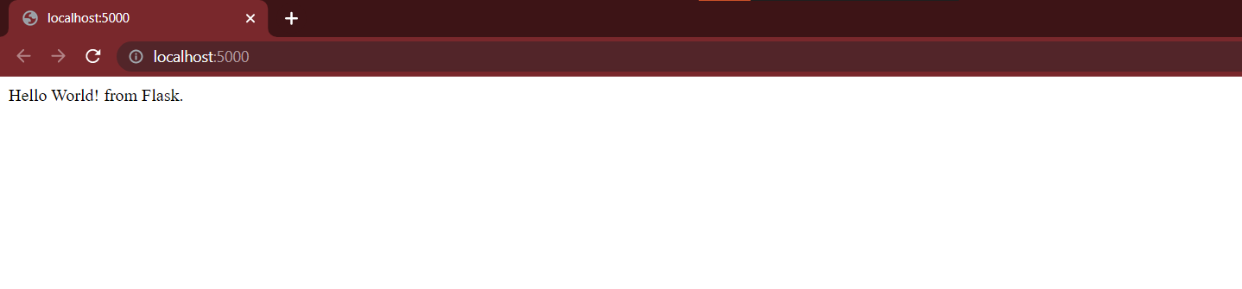

3. Create a IBM container registry and deploy helloworld app.

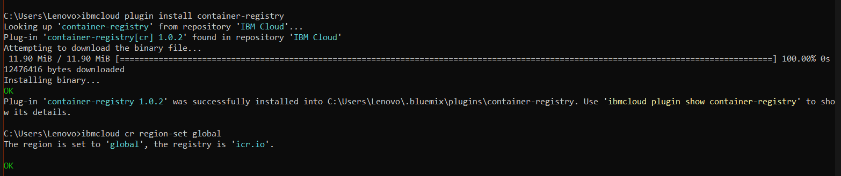

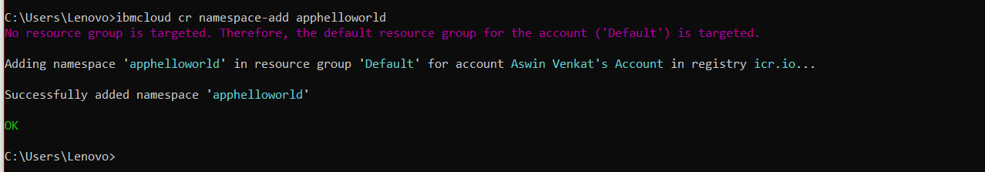

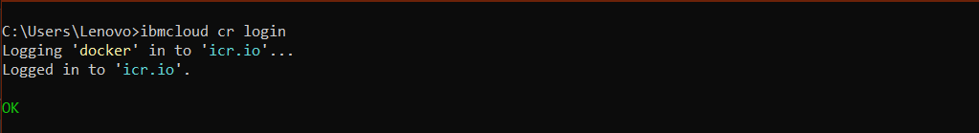

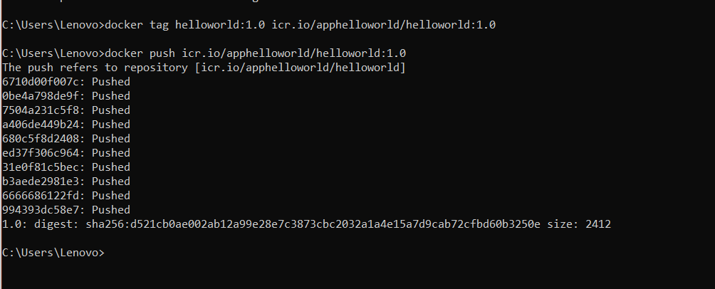

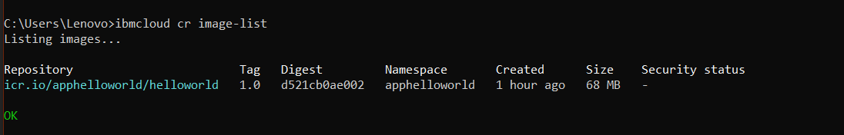

The image is pushed to the namespace.

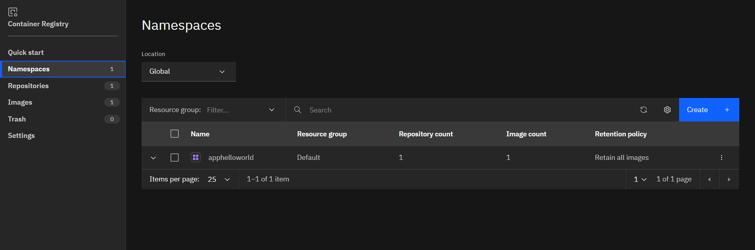

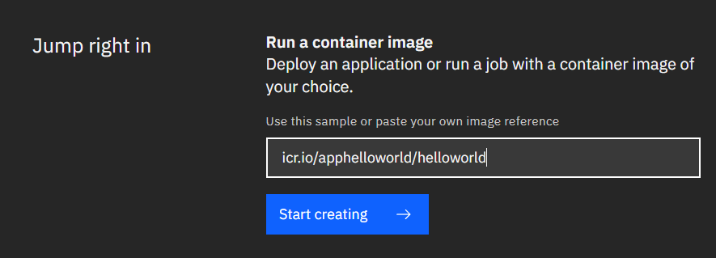

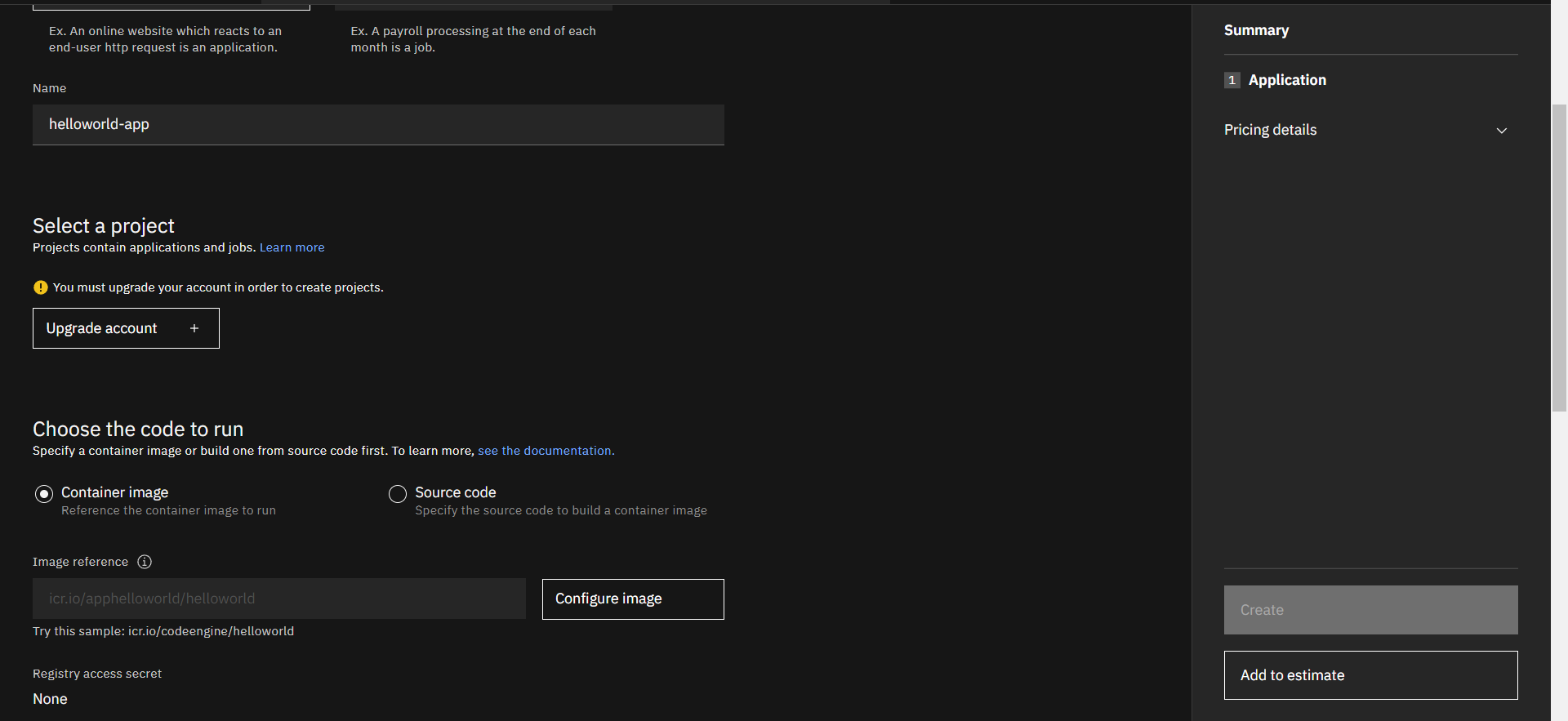

4. Create a Kubernetes cluster in IBM cloud and deploy helloworld image and also expose the same app to run in nodeport.

Cluster:

